ASUS Announces New ZenBook 13 OLED (UM325) and ZenBook 14 (UM425)
World’s lightest OLED AMD laptop with FHD OLED HDR NanoEdge display, and one of the thinnest 14" AMD laptops, powered by Ryzen 5000 U-Series and H-Series CPUs

KEY POINTS
- Compact portability: ZenBook 13 OLED has compact, elegant all-metal 13.9 mm-thin chassis; weighs as little as 1.14 kg; up to 16 hr battery life; 2 gorgeous colors
- Premium performance: Latest AMD® Ryzen™ 5000 U-Series and H-Series CPUs, up to 16 GB RAM, PCIe® SSDs and the latest WiFi 6 (802.11ax)
- Amazing ultra-vivid OLED display: ZenBook 13 OLED has a four-sided FHD OLED HDR NanoEdge display that delivers exceptionally realistic visuals
- Ergonomic design: Edge-to-edge keyboard, ASUS NumberPad, ErgoLift hinge, and IR camera
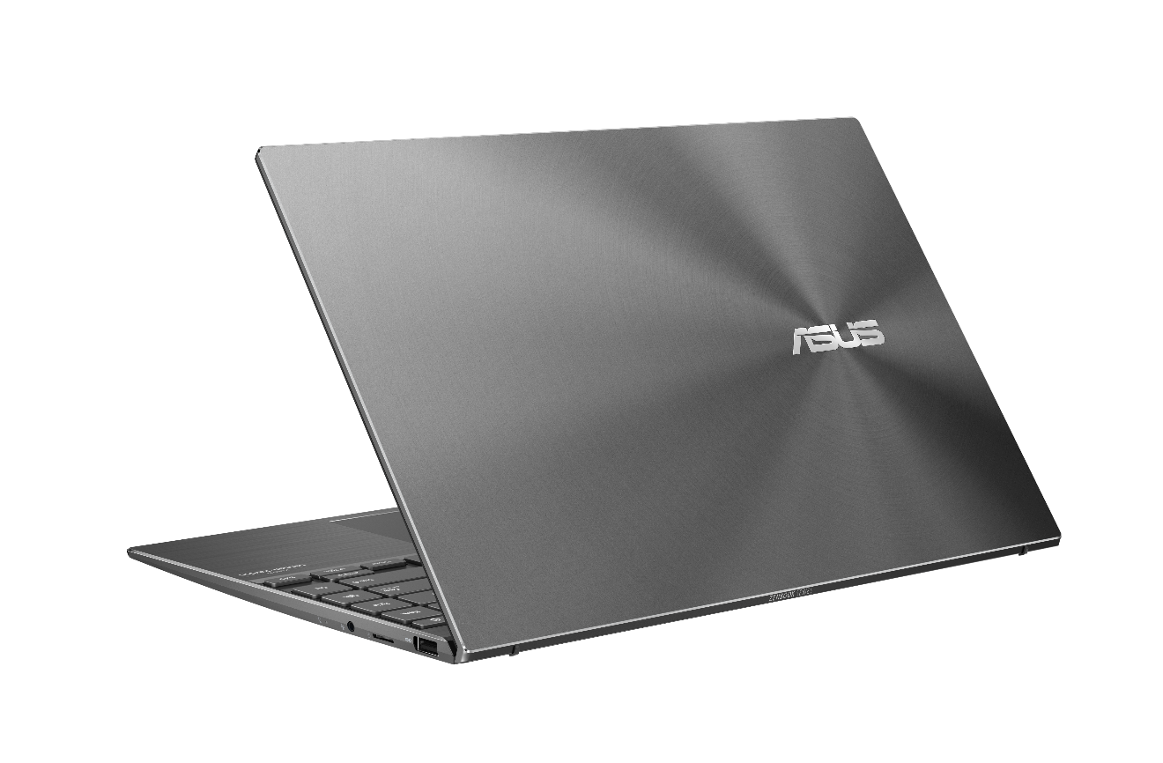
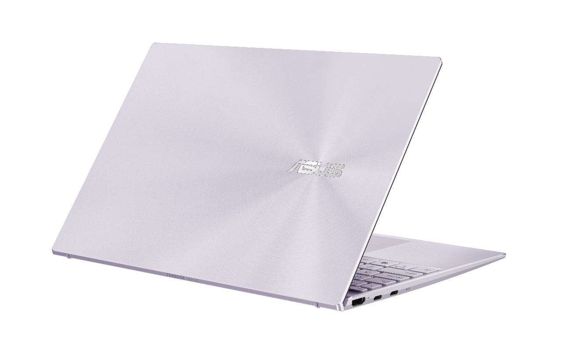
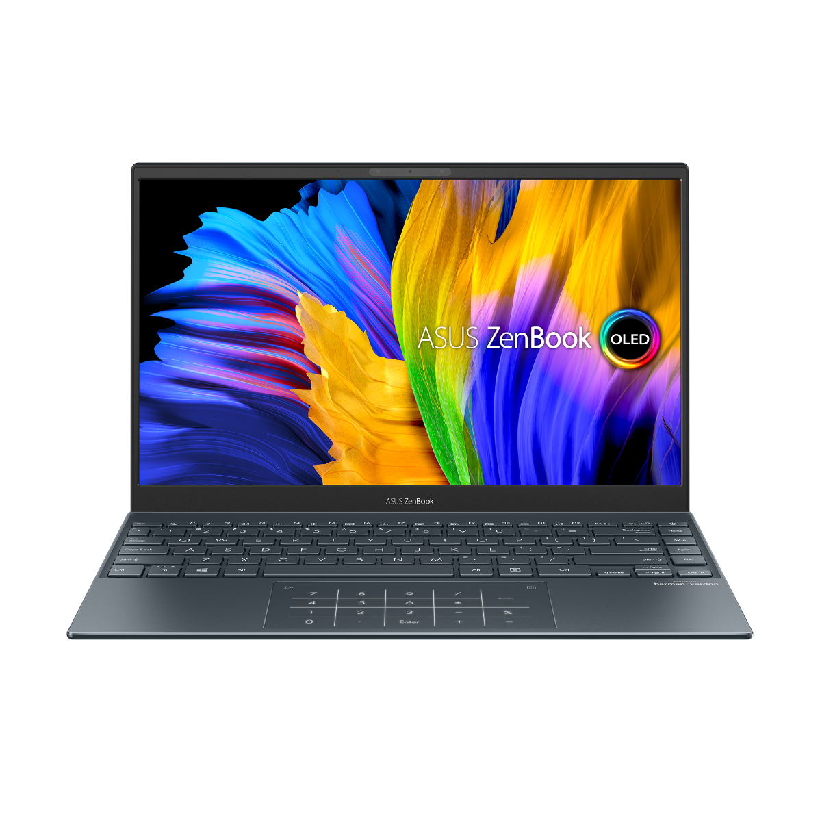
TAIPEI, Taiwan, January 14, 2021 — ASUS today announced ZenBook 13 OLED (UM325) and ZenBook 14 (UM425), new-generation 13-inch and 14-inch ultraportable AMD®-powered laptops in the ZenBook Classic series.
The ultralight 1.14 kg ZenBook 13 OLED is the world's lightest OLED AMD laptop. With a thin and light all-metal design, it features a four-sided FHD OLED HDR NanoEdge display with an 88% screen-to-body ratio that gives it a compact footprint.
ZenBook 14 is one of the world’s thinnest 14-inch AMD laptops, with an ultra-slim 14.3 mm profile and up to 16-hour battery life that make it the ideal traveling companion. With its beautifully crafted classic design and travel-friendly features, ZenBook 14 will make your on-the-go lifestyle more effortless than ever.
A compact four-sided NanoEdge display offers an up to 90% screen-to-body ratio for immersive visuals. The user experience is also fully updated, featuring ASUS NumberPad 2.0, a new edge-to-edge keyboard design, ErgoLift hinge, and an IR camera for fast face-recognition.
Powered by the latest AMD Ryzen™ 5000 U-Series and Ryzen 5000 H-Series mobile processors with up to 16 GB RAM, ZenBook 13 OLED and ZenBook 14 make light work of multitasking, productivity and entertainment. Up to 1 TB PCIe® x2 SSDs and the latest WiFi 6 (802.11ax) round off the specification for superb all-round performance.

Compact portability
The latest ZenBook 13 OLED and ZenBook 14 are designed for effortless portability, with compact and elegant all-metal chassis that are a mere 13.9 mm and 14.3 mm thin respectively. ZenBook 13 OLED and ZenBook 14 are also incredibly power efficient, with up to an amazing 16 hours of battery life on a single charge, meaning that the charger can be left at home for many trips to minimize weight and bulk. They are a perfect match for today's on-the-go lifestyles.
The stylish new design of ZenBook 13 OLED and ZenBook 14 is enhanced by two timeless new color options. Pine Grey is a glossy shade that is calm and peaceful. It projects professional wisdom and features a special off-center version of the iconic ZenBook spun-metal finish. Lilac Mist conveys a subtle touch of high-end luxury. Elegant and modern, charming and sophisticated, this gorgeous matte shade is a perfect match for the classic ZenBook spun-metal finish.

Premium performance
Performance is a crucial part of the ZenBook experience. ZenBook 13 OLED and ZenBook 14 are powered by AMD Ryzen 5000 U-Series and Ryzen 5000 H-Series mobile processors that deliver ultrafast responsiveness even for demanding tasks.
The Ryzen 5000 Series Mobile Processors deliver the fastest, smoothest and most premium performance ever. With up to 16 GB of high-speed RAM, daily tasks won't become chores. High-speed solid-state storage, using PCIe 3.0 x2 SSDs, ensures fast boot times and near-instant app loading.
ASUS offers a comprehensive range of wireless connectivity solutions. The WiFi 6 in ZenBook 13 OLED and ZenBook 14 allows users to load online content in the blink of an eye, and it’s made even better by ASUS WiFi Master technology, which includes ASUS WiFi Stabilizer and ASUS WiFi SmartConnect. For rock-solid stability in WiFi connections, WiFi Stabilizer filters out wireless interference, so users will always enjoy the fastest possible speeds. WiFi SmartConnect automatically selects the best WiFi source, so the laptop connects seamlessly to the best WiFi signal and known mobile hotspots.

Amazing ultra-vivid OLED display
The amazing FHD OLED HDR NanoEdge display on ZenBook 13 OLED delivers stunningly detailed and realistic visuals, with ultra-vivid, true-to-life colors at any brightness level. It's PANTONE® Validated for outstanding color accuracy, boasts a cinema-grade 100% DCI-P3 color gamut, and has an ultrafast response time for blur-free action scenes. It's also VESA DisplayHDR™ 500 True Black certified for deep blacks and increased dynamic range, delivering enhanced realism and superb shadow detail. Its low blue-light levels are TÜV Rheinland-certified for better eye care, making this immersive slim-bezel display is a superb all-rounder for work or play.
Both ZenBook 13 OLED and ZenBook 14 have a four-sided NanoEdge display design, with a slim bezel that creates an up to 90% screen-to-body ratio for a more immersive viewing experience and a compact footprint.

Ergonomic design
The new edge-to-edge ergonomic keyboard design increases the size of the keyboard for a more comfortable typing experience. It also creates space for an extra set of useful function keys at the right-hand side of the keyboard. For maximum typing comfort, the precision engineered ErgoLift hinge automatically tilts the keyboard to the optimum typing angle when the lid is opened. This action also creates space under the laptop for extra cooling airflow.
For easy data entry, there’s the productivity-enhancing ASUS NumberPad 2.0. This is a dual-function touchpad with an integrated LED-illuminated full-size numeric keypad: simply tapping the icon on the touchpad turns NumberPad on and off.
An integrated infrared (IR) camera located on the bezel makes password-free face login fast and easy with Windows Hello. It also works in dim lighting conditions, so accessing ZenBook 13 OLED and ZenBook 14 is easier and faster than ever in any environment.
AVAILABILITY & PRICING
ASUS ZenBook 13 OLED (UM325) and ASUS ZenBook 14 (UM425) will be available from DATE in COUNTRIES from PLACES. Please contact your local ASUS representative for further information.

PRESS CONTACTS
Edward Ker  Product Marketer  Edward_Ker@asus.com | Contact Name 2  Job Title  contact_2_email

NOTES TO EDITORS
Product video: (TBD)
ASUS ZenBook 13 OLED (UM325): https://asus.me/ZenBook13OLED
ASUS ZenBook 14 (UM425QA): https://asus.me/ZenBook14UM425QA
ASUS ZenBook 14 (UM425UA):https://asus.me/ZenBook14UM425UA
ASUS ZenBook 14 (UM425UG):https://asus.me/ZenBook14UM425UG
ASUS Global Press Room: http://press.asus.com
ASUS Global Facebook: http://www.facebook.com/asus
ASUS Global Twitter: http://www.twitter.com/asus

SPECIFICATIONS

ASUS ZenBook 13 OLED (UM325)

Processor | (UM325SA)  AMD® Ryzen™ 7 5800U Mobile Processor  AMD® Ryzen™ 5 5600U Mobile Processor  (UM325UA)  AMD® Ryzen™ 7 5700U Mobile Processor  AMD® Ryzen™ 5 5500U Mobile Processor
Display | 13.3" (16:9) OLED, Full HD (1920 x 1080) NanoEdge display  DCI-P3: 100%、VESA DisplayHDR™ True Black certified  TÜV Rheinland-certified eye care  88% screen-to-body ratio  2.9mm-thin side bezel  Wide-view technology
Operating system | Windows 10 Pro  Windows 10 Home
Graphics | AMD® Radeon™ Graphics
Main memory | Up to 16 GB 3733 MHz LPDDR4x
Storage | Up to 1 TB M.2 NVMe™ PCIe® 3.0 SSD
Connectivity | WiFi 6 (802.11ax)  WiFi 5 (802.11ac)  Bluetooth® 5.0
Camera | IR webcam with Windows Hello support
I/O ports | 2 x USB 3.2 Gen 2 Type-C®  1 x USB 3.2 Gen 1 Type-A  1 x Standard HDMI  1 x MicroSD card reader
Touchpad | ASUS NumberPad 2.0
Audio | Harman Kardon-certified audio system ASUS SonicMaster stereo audio system with surround-sound; smart amplifier for maximum audio performance  Array microphone with Cortana and Alexa voice-recognition support
Battery | 67 Wh 4-cell lithium-polymer battery
Colors | Pine Grey, Lilac Mist
Dimensions | 304 x 203 x 13.9 mm
Weight | approx. 1.14 kg

ASUS ZenBook 14 (UM425)

Processor | (UM425QA)  AMD® Ryzen™ 7 5800H Mobile Processor  AMD® Ryzen™ 5 5600H Mobile Processor  (UM425UA/UM425UG)  AMD® Ryzen™ 7 5700U Mobile Processor  AMD® Ryzen™ 5 5500U Mobile Processor
Display | 14" (16:9) Full HD (1920 x 1080) NanoEdge display  90% screen-to-body ratio  2.5mm-thin side bezel  IPS-level wide-view technology
Operating system | Windows 10 Pro  Windows 10 Home
Graphics | Up to NVIDIA® GeForce® MX450
Main memory | Up to 16 GB 4266 MHz LPDDR4x
Storage | Up to 1 TB M.2 NVMe™ PCIe® 3.0 SSD
Connectivity | WiFi 6 (802.11ax)  WiFi 5 (802.11ac)  Bluetooth® 5.0
Camera | IR webcam with Windows Hello support
I/O ports | 2 x USB 3.2 Gen 2 Type-C®  1 x USB 3.2 Gen 1 Type-A  1 x Standard HDMI  1 x MicroSD card reader  1 x combo audio jack
Touchpad | ASUS NumberPad 2.0
Audio | Harman Kardon-certified audio system ASUS SonicMaster stereo audio system with surround-sound; smart amplifier for maximum audio performance  Array microphone with Cortana and Alexa voice-recognition support
Battery | 67 Wh 4-cell lithium-polymer battery
Colors | (UM425UA) Pine Grey, Lilac Mist  (UM425QA) Pine Grey  (UM425UG) Light Grey
Dimensions | 319 x 210 x 14.3 mm
Weight | approx. 1.22 kg

About ASUS
ASUS is a multinational company known for the world’s best motherboards, PCs, monitors, graphics cards and routers, and driven to become the most-admired innovative leading technology enterprise. With a global workforce that includes more than 5,000 R&D professionals, ASUS leads the industry through cutting-edge design and innovations made to create the most ubiquitous, intelligent, heartfelt and joyful smart life for everyone. Inspired by the In Search of Incredible brand spirit, ASUS won more than 11 prestigious awards every day in 2019 and ranked as one of Forbes’ Global 2000 Top Regarded Companies, Thomson Reuters’ Top 100 Global Tech Leaders and Fortune’s World’s Most Admired Companies.

According to overall laptop weight, as of December 8, 2020 based on internal ASUS market analysis comparing ZenBook 13 OLED to competing clamshell AMD laptops with a 13.3-inch OLED screen from vendors including HP, Razer and Gigabyte. ZenBook 13 OLED ranked first in terms of weight.
According to overall laptop thinness, as of Nov 5, 2020 based on internal ASUS market analysis comparing ZenBook 14 to competing convertible laptops with a screen measuring 14 inches from vendors including Acer, HP, Huawei, Dell, Lenovo, Honor, ZenBook 14 ranked top-three in regards of model thinness.
ZenBook 13 OLED (UM325): Battery tests conducted by ASUS on December, 4, 2020 using the 1080p Video Playback scenario. Test configuration: ZenBook UM325SA, FHD OLED panel, AMD R5-5600U, 256G GB SSD, 16GB RAM. Test settings: WiFi enabled but disconnected (not connected to any access point), Windows Power Plan set to Balanced, display brightness set to 150 cd/m2, NumberPad off. Actual battery life may vary depending on product configuration, usage, operational conditions and power management settings. Battery life will decrease over the lifetime of the battery. ZenBook 14 (UM425): Battery tests conducted by ASUS on December, 1st, 2020 using the 1080p Video Playback scenario. Test configuration: ZenBook 14 UM425UA, FHD 250 nits panel, AMD R7-5700U, 1 TB SSD, 16 GB RAM. Test settings: WiFi enabled but disconnected (not connected to any access point), Windows Power Plan set to Balanced, display brightness set to 150 cd/m2, NumberPad off. Actual battery life may vary depending on product configuration, usage, operational conditions and power management settings. Battery life will decrease over the lifetime of the battery.
Please note that all versions of NumberPad only work with the Microsoft Windows operating system.
Color options may vary by model. Only ZenBook 13 OLED (UM325) and ZenBook 14 (UM425UA) have two color options.
ASUS OLED panels are only available on ZenBook 13 OLED (UM325). ZenBook 14 (UM425) models use IPS panels.
For ZenBook 13 OLED, the stated 2.9 mm width of the side bezel is the distance between the edge of the non-active screen display area and the inside edge of the case. If the case width is included, the side bezel width is 4.4 mm. Measured based on standard (anti-glare) display configuration. The top bezel width is 6.5 mm and the bottom bezel width is 12.9 mm. For ZenBook 14, the stated 2.5 mm width of the side bezel is the distance between the edge of the non-active screen display area and the inside edge of the case. If the case width is included, the side bezel width is 4.65 mm. Measured based on standard (anti-glare) display configuration. The top bezel width is 8.9 mm and the bottom bezel width is 11.1 mm.
Specifications, content and product availability are all subject to change without notice and may differ from country to country. Actual performance may vary depending on applications, usage, environment and other factors. Full specifications are available at http://www.asus.com

