OV-NEOxl40A9S | NEOxl 40 3u/40-slot base/1-drive/LTO9 SAS
OV-NEOxl409F | NEOxl 40 3u/40-slot base/1-drive/LTO9 FC
OV-NEOxl40PWR | NEOxl 40 Redundant Power Option
EW-XL40GLD3UP | OverlandCare Gold Warranty Coverage, 3-year uplift, NEOxl 40 Base (support coverage includes: base module + up to 3 drives)
Promotion Code: MC-38848
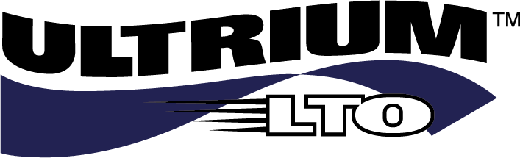
Promotion Details
Buy NEOxl 40 3u LTO-9 SAS or FC together with Redundant Power and OverlandCare Gold warranty and receive 20% off
Terms & Conditions
- In case of any dispute in respect to this incentive promotion, the decision of Overland-Tandberg shall be final and binding.
- Overland-Tandberg reserves the right to amend or cancel this incentive promotion at any time without notice.
- No cash alternatives will be offered.
- Overland-Tandberg reserves the right to disqualify any partner from the promotion for any reason.
- The reseller and distributor must be a registered Overland-Tandberg partner and have a valid Partner Portal Login.
- The promotion is valid for all resellers that purchase from an authorized Overland Storage, Tandberg Data or Overland-Tandberg distributor.
- Participation in the promotion is deemed to be acceptance of these Terms and Conditions as well as other Terms and Conditions associated with the promotional items.
- All promotional opportunities may be taken advantage of via a Meet Comp.
- Qualifying purchase orders must be received by March 31, 2022.
- All promotional discounts are subject to availability.
Datasheets: NEOxl 40
Customer Benefits
- LTO Tape is the industry standard for regulatory compliance and data archiving
- As removable media, tape is that last line of defense for data protection and ransomware
- Enables business continuity in case of disaster, human error, malware and other cyberattacks
- Optimize I/O workloads by offloading recent backups from disk to tape (nearline storage)
- Lowest overall cost for persistent, long-term data archiving
- Maximum capacity (LTO-9): NEO xl40 – 3u / 40-slot: Native: 720TB; Compressed: 1.8PB*
* Assumes 2.5:1 compression
For more information contact:
00 800 8263 2374
salesemea@overlandtandberg.com
These incredible savings expire
March 31, 2022
Sales and support for Overland-Tandberg products and solutions are available in over 100 countries.
Contact us today at salesemea@overlandtandberg.com. Visit OverlandTandberg.com.
©2022 Overland-Tandberg. All trademarks and registered trademarks are the property of their respective owners. The information contained herein is subject to change without notice and is provided “as is” without warranty of any kind. Overland-Tandberg shall not be liable for technical or editorial errors or omissions contained herein.
Wherever your enterprise data takes you, NEO LTO-9 solutions let you keep pace ─ for today’s requirements and tomorrow’s digital opportunities.

2022 Q1 EMEA Reseller Promotion
NEO®xl 40
20% Rebate Promotion

