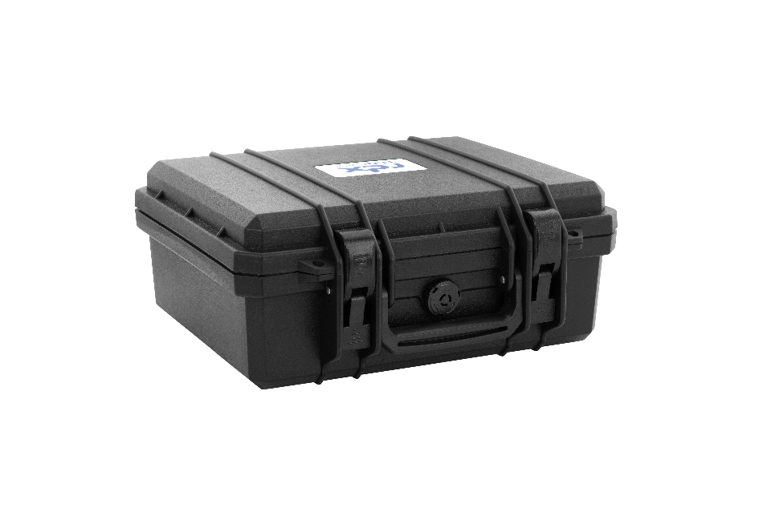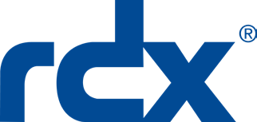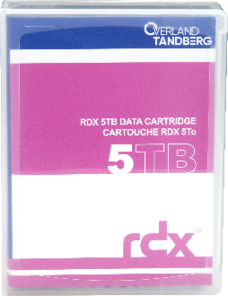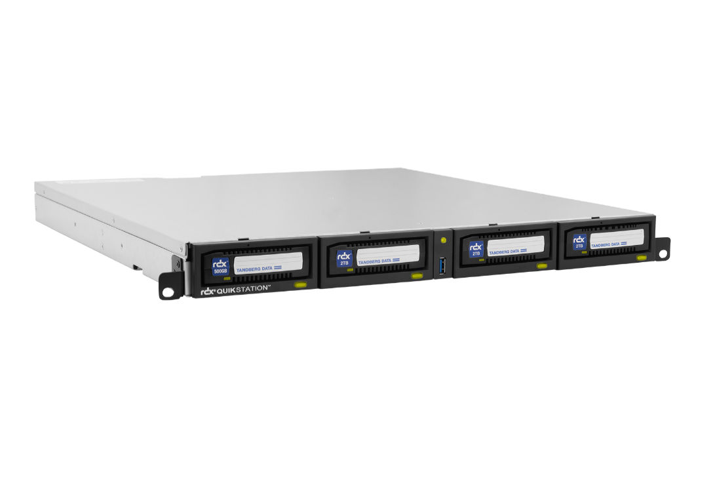­

**20% off!**

**Terms & Conditions**

1. In case of any dispute in respect to this incentive promotion, the   
   decision of Overland-Tandberg shall be final and binding.
2. Overland-Tandberg reserves the right to amend or cancel this incentive promotion at any time without notice.
3. No cash alternatives will be offered.
4. Overland-Tandberg reserves the right to disqualify any partner from the promotion for any reason.
5. The reseller and distributor must be a registered Overland-Tandberg partner and have a valid Partner Portal Login.
6. The promotion is valid for all resellers that purchase from an authorized Overland Storage, Tandberg Data or Overland-Tandberg distributor.
7. Participation in the promotion is deemed to be acceptance of these Terms and Conditions as well as other Terms and Conditions associated with the promotional items.
8. All promotional opportunities may be taken advantage of via a Meet Comp.
9. Promotion may only be used three (3) times per partner.
10. Qualifying purchase orders must be received by March 31, 2022.
11. Promotional discounts are subject to availability.

*RDX QuikStation 8 Rackmount*

*RDX TENCASE*

*RDX 5TB HDD Cartridges*

*RDX QuikStation 4 Rackmount*

The data protection and secure storage standard for today’s fast-growing SMB and SME organizations

2022 Q1 EMEA Reseller Promotion

RDX® QuikStation®

20% Rebate Promotion

Promotion Details

* **Buy RDX QuikStation 4 with four (4) 5TB RDX HDD cartridges and a TENCASE and receive 20% off**
* **Buy RDX QuikStation 8 with eight (8) 5TB RDX HDD cartridges and a TENCASE and receive 20% off**

|  |  |
| --- | --- |
| 8920-RDX | RDX QuikStation 4 RM, 4-Bay, 4x 1Gb Ethernet, removable disk array, 1U rackmount |
| 8945-RDX | RDX QuikStation 8 RM, 8-bay, 2x 10Gb Ethernet, removable disk array, 2U rackmount |
| 8862-RDX | Tandberg RDX 5TB HDD Cartridge (single)* |
| 1022291 | RDX TENCASE, Transportation Case for 10 RDX Cartridges |
| **Promotion Code:** **MC-38815** *(limited to 3 uses per partner)* | |

**Datasheets:** [RDX QuikStation](https://ftp1.overlandtandberg.com/website/website/DS_RDX_QuikStation_US.pdf), [RDX HDD Cartridges](https://ftp1.overlandtandberg.com/website/website/DS_RDX_Media_US.pdf)

**For more information contact:**

**00 800 8263 2374**

[salesemea@overlandtandberg.com](mailto:salesemea@overlandtandberg.com)

These extraordinary savings expire  
March 31, 2022

**Your Customer’s Benefits**

#### Flexible and easy to manage

* Supports on-premises, distributed, and hybrid-cloud architectures
* Use for automated data protection, disaster recovery, and archiving
* Provides emulation modes for RDX, logical volumes, tape library, tape, and disk autoloader as well as a hybrid mode (QxS-8 only)
* Supports Windows, Linux, and Mac OS

#### Overcome capacity limitations

* Quickly scale with removable cartridges
* Scales up to 20TB (per 4u), and up to 40TB (per 8u)
* Partition data over several RDX cartridges, or as a single logical volume

#### Seamless network integration

* iSCSI connectivity for integration into virtual, physical, or hybrid environments
* Gigabit Ethernet (GbE) ports ensure fast access to data: 1GbE (x4) ─ QxS-4; 10GbE (x2) ─ QxS-8

#### Foolproof data protection

* Use for offline and/or off-site storage
* Provides automatic air-gap security protection against ransomware and other cyberthreats
* Supports all major backup and encryption software

Sales and support for Overland-Tandberg products and solutions are available in over 100 countries.

Contact us today at [salesemea@overlandtandberg.com.](mailto:salesemea@overlandtandberg.com.) Visit OverlandTandberg.com.

©2022 Overland-Tandberg. All trademarks and registered trademarks are the property of their respective owners. The information contained herein is subject to change without notice and is provided “as is” without warranty of any kind. Overland-Tandberg shall not be liable for technical or editorial errors or omissions contained herein.

©2022 Overland-Tandberg. All trademarks and registered trademarks are the property of their respective owners. The information contained herein is subject to change without notice and is provided “as is” without warranty of any kind. Overland-Tandberg shall not be liable for technical or editorial errors or omissions contained herein.

