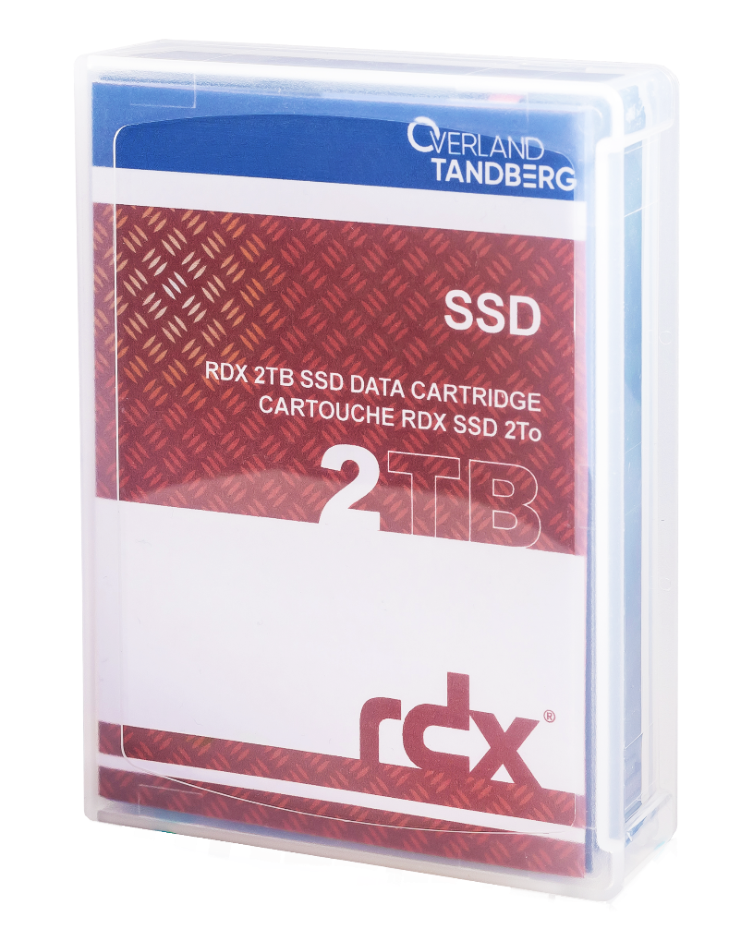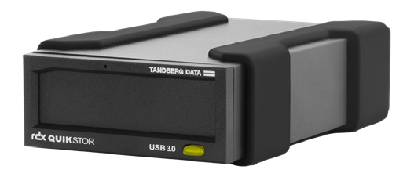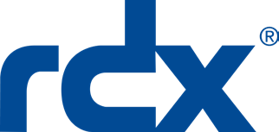

**Terms & Conditions**

1. In case of any dispute in respect to this incentive promotion, the deci­sion of  
   Overland-Tandberg shall be final and binding.
2. Overland-Tandberg reserves the right to amend or cancel this incentive promotion   
   at any time without notice.
3. No cash alternatives will be offered.
4. Overland-Tandberg reserves the right to disqualify any partner from the promotion for any reason.
5. The reseller and distributor must be a registered Overland-Tandberg partner and  
   have a valid Partner Portal Login.
6. The promotion is valid for all resellers that purchase from an authorized Overland Storage, Tandberg Data or Overland-Tandberg distributor.
7. Participation in the promotion is deemed to be acceptance of these Terms and Conditions as well as other Terms and Conditions associated with the promotional items.
8. All promotional opportunities may be taken advantage of via a Meet Comp.
9. Promotion is limited to five (5) orders per account.
10. Qualifying purchase orders must be received by March 31, 2022.
11. Promotional discounts are subject to availability.

**For more information contact:**

**00 800 8263 2374**

salesemea@overlandtandberg.com

These incredible savings expire March 31, 2022

**Your Customer’s Benefits**

* Blistering SSD speed **as much as 2X** **performance** or faster vs. standard HDD
* Shrink backup windows from **hours to minutes**
* High speed backup and restores for critical **applications**, **unstructured** and **large data** sets
* Extremely fast backup and **disaster recovery**
* RDX Manager software controls cartridge eject and provides **automatic** **air-gap security** protection against ransomware *(requires   
  software download)*
* Supports all major backup and encryption software
* Shock-proof design
* Plug-n-Play setup
* Pocket-sized portability
* Protection for laptops, tablets and mobile devices (Windows, iOS, Android)

**20**%

**Receive   
20% off!**

**and three RDX SSD 2TB Data Cartridges**

**Buy one external**

**RDX System...**

**Datasheets:** [RDX QuikStor](https://ftp1.overlandtandberg.com/website/website/DS_RDX_QuikStor_US.pdf), [RDX SSD Cartridges](https://ftp1.overlandtandberg.com/public/DS_RDX_SSD_Media_US.pdf)

|  |  |
| --- | --- |
| 8782-RDX | Tandberg RDX External drive, black, USB3+ interface |
| 8878-RDX | Overland-Tandberg RDX SSD 2TB Cartridge (single) |
| **Promotion Code: MC-38814** *(Limit 5 orders per account)* | |

2022 Q1 EMEA Reseller Promotion

RDX® QuikStor® + SSD Promotion

Do your SOHO or SMB Customers have a need for speed when it comes to backup and disaster recovery?

Our RDX® QuikStor® removable disk system with SSD Cartridges takes the worry out of shrinking backup windows, as well as enabling faster disaster recovery, and secure business continuity.

Sales and support for Overland-Tandberg products and solutions are available in over 100 countries.

Contact us today at salesemea@overlandtandberg.com. Visit OverlandTandberg.com.

©2022 Overland-Tandberg. All trademarks and registered trademarks are the property of their respective owners. The information contained herein is subject to change without notice and is provided “as is” without warranty of any kind. Overland-Tandberg shall not be liable for technical or editorial errors or omissions contained herein.

